Fraudulent transaction Analysis

-- data cleaning
describe fraud_Transaction;

update fraud_Transaction set transactiontime=str_to_date(transactiontime,'%d-%m-%Y %H:%i:%s');

alter table fraud_data
modify column transactiontime date;

add two columns in the dataset
alter table fraud_transaction
add column Transaction_time time,
add column Transaction_date date;

update value to new columns
update fraud_transaction set transaction_date=str_to_date(TransactionTime,'%d-%m-%Y %H:%i:%s'),
transaction_time=str_to_date(TransactionTime,'%d-%m-%Y %H:%i:%s');

-- KPI
-- TotalTarnsactions
select count(*) as totalTransaction from fraud_transaction;

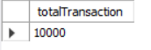

-- total fraud
select count(customerid) as fraudTransaction from fraud_transaction
where fraudflag=1;

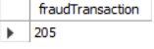

-- total transaction amount
select round(sum(amount),0) as totalamount from fraud_transaction;

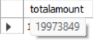

-- fraud_transaction
select round(sum(amount),0) as fraudamount from fraud_transaction
where fraudflag=1;

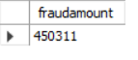
-- total customer
select count(distinct customerid) as totalcustomer from fraud_transaction;

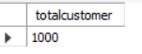

-- fraud percentage
select concat(round(count(case when fraudflag=1 then 1 end) *100/count(*),2),'%') as fraud_percentage
from fraud_transaction;

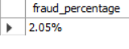

-- monthly transaction trend
SELECT
MONTHNAME(transaction_date) AS monthName,
ROUND(SUM(amount), 1) AS totalamount,
ROUND(SUM(CASE
WHEN fraudflag = 1 THEN amount
ELSE 0
END),
1) AS fraud_Amount
FROM
fraud_transaction
GROUP BY MONTHNAME(transaction_date)
ORDER BY MONTHNAME(transaction_date);

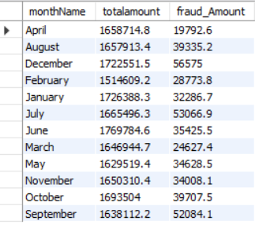

-- calculate Average transaction by location
SELECT
location, ROUND(AVG(amount), 2) AS avg_amount
FROM
fraud_transaction
GROUP BY location;

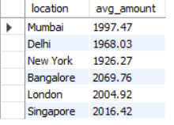

-- calculate total amount,total amount lost due to fraud per location
SELECT
location,
round(sum(Amount),2) as TotalAmount,
round(sum(CASE
WHEN fraudflag = 1 THEN amount else 0
END),2) AS fraudAmount
FROM
fraud_transaction
GROUP BY location;

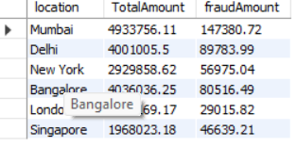

-- fraud by device
SELECT
device,
COUNT(*) AS TotalTransaction,
COUNT(CASE
WHEN fraudflag = 1 THEN 1
END) AS fraudcount
FROM
fraud_transaction
GROUP BY device
ORDER BY fraudcount DESC;

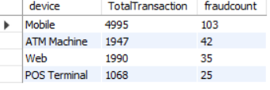

-- fraud by transaction_type
SELECT
TransactionType,
COUNT(*) AS TotalTransaction,
COUNT(CASE
WHEN fraudflag = 1 THEN 1
END) AS fraudcount,
round(sum(amount),1) as TotalAmount,
round(sum(case when fraudflag = 1 then amount else 0 end),1) as fraudAmount
FROM
fraud_transaction
GROUP BY TransactionType
ORDER BY fraudcount DESC;

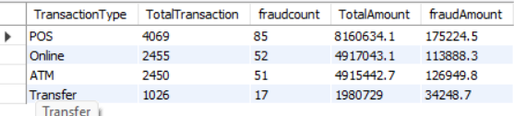

-- Find Peak Transaction hours
SELECT
HOUR(transaction_time) AS transaction_hour,
COUNT(*) AS TotalTransaction,
count(case when fraudflag = 1 then 1 end) as FraudCount,
round(sum(amount),1) as totalamount,
round(sum(case when fraudflag = 1 then amount else 0 end),1) as fraudAmount
FROM
fraud_transaction
GROUP BY transaction_hour
ORDER BY FraudCount desc;

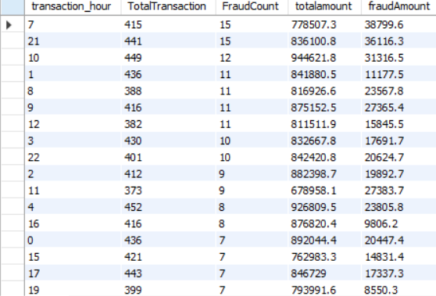

-- MOM % and difference Total Transaction
with mom_transaction as (
SELECT
MONTH(Transaction_date) AS month, COUNT(1) AS transaction_count
FROM
fraud_transaction
GROUP BY MONTH(Transaction_date)
ORDER BY MONTH(Transaction_date)
)
select month, transaction_count,
transaction_count-lag(transaction_count) over (order by month) as Difference,
round(((transaction_count-lag(transaction_count) over (order by month))/
lag(transaction_count) over (order by month))*100,1) as percentage
from mom_transaction;

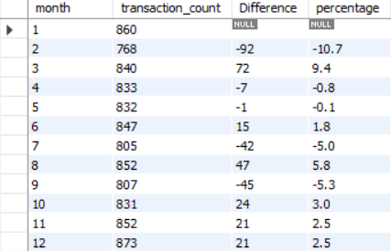

-- MOM % totalCustomerr
with mom_transaction as (
SELECT
MONTH(Transaction_date) AS month,
COUNT(DISTINCT customerid) AS customercount
FROM
fraud_transaction
GROUP BY MONTH(Transaction_date)
ORDER BY MONTH(Transaction_date)
)
select month, customercount,
lag(customercount) over (order by month) as difference,
round(((customercount-lag(customercount) over (order by month))/lag(customercount) over (order by month))*100,1) as percentage
from mom_transaction;

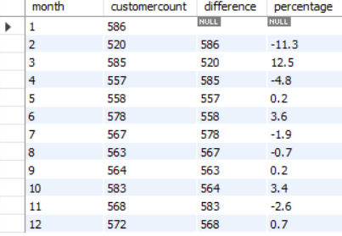

-- MOM % and difference totaFraudlAmount
with mom_transaction as
(
SELECT
MONTH(Transaction_date) AS month,
ROUND(SUM(CASE
WHEN fraudflag = 1 THEN amount
ELSE 0
END),
1) AS totalFraudamount
FROM
fraud_transaction
GROUP BY MONTH(Transaction_date)
ORDER BY MONTH(Transaction_date)
)
select month, totalFraudamount,
round(lag(totalFraudamount) over (order by month),1)as prev_month_Fraud_amount,
round(totalFraudamount-lag(totalFraudamount) over (order by month),1) as Difference,
round(((totalFraudamount-lag(totalFraudamount) over (order by month))/lag(totalFraudamount) over (order by month))*100,1) as percentage
from mom_transaction;

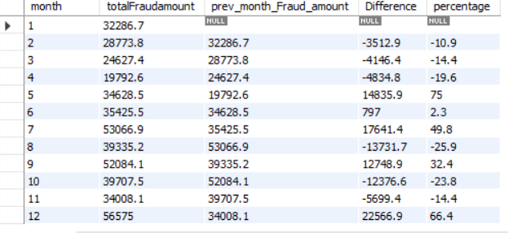

-- MOM % and difference totalAmount
with mom_transaction as (
SELECT
MONTH(Transaction_date) AS month,
ROUND(SUM(amount), 0) AS totalamount
FROM
fraud_transaction
GROUP BY MONTH(Transaction_date)
ORDER BY MONTH(Transaction_date)
)
select month, totalamount,
lag(totalamount) over (order by month) as prev_month_amount,
totalamount-lag(totalamount) over (order by month) as difference,
round(((totalamount-lag(totalamount) over (order by month))/lag(totalamount) over (order by month))*100,1) as percentage
from mom_transaction;

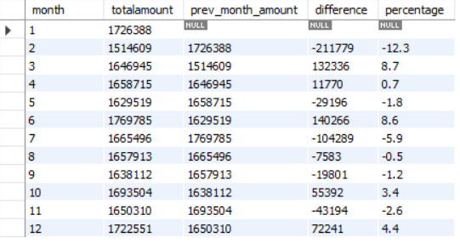

-- Calculate number of transaction and total amount by week
SELECT
DAYNAME(transaction_date) AS day_of_week,
COUNT(*) AS totaltransaction,
round(SUM(amount),1) AS totalAmount,
round(SUM(CASE
WHEN fraudflag = 1 THEN amount
ELSE 0
END),1) AS FraudAmount,
CONCAT(ROUND(COUNT(CASE
WHEN fraudflag = 1 THEN 1
END) * 100 / COUNT(*),
2),
'%') AS fraud_percentage
FROM
fraud_transaction
GROUP BY DAYNAME(transaction_date)
ORDER BY fraud_percentage desc;

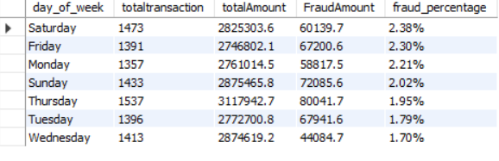

-- top 5 customer with higest fraud amount
with higestfraudamount as (
SELECT
customerid,
SUM(CASE
WHEN FraudFlag = 1 THEN amount
ELSE 0
END) AS fraud_amount
FROM
fraud_transaction
GROUP BY customerid
),
rank_fraud as
(
select *,
rank()over(order by fraud_amount desc) as rnk
from higestfraudamount
)
select * from rank_fraud
where rnk<=5

SELECT
customerid, SUM(amount)
FROM
fraud_transaction
WHERE
FraudFlag = 1
GROUP BY customerid
ORDER BY SUM(amount) DESC
LIMIT 5;

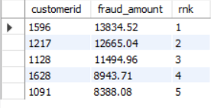

-- fraud trend by customer
with fraud_trend as (
SELECT
customerid,
COUNT(1) AS totaltransaction,
COUNT(CASE
WHEN fraudflag = 1 THEN 1
END) AS fraud_transaction_per_customer,
sum(amount) as totalAmount,
sum(case when fraudflag=1 then amount end) as fraud_amount_per_customer
FROM
fraud_transaction
GROUP BY customerid)
SELECT
customerid,
totaltransaction,
fraud_transaction_per_customer,
fraud_amount_per_customer,
ROUND((fraud_transaction_per_customer / totaltransaction) * 100,
2) AS fraud_percentage,
CASE
WHEN
ROUND((fraud_transaction_per_customer / totaltransaction) * 100,
2) > 40
THEN
'High Risk'
WHEN
ROUND((fraud_transaction_per_customer / totaltransaction) * 100,
2) > 20
THEN
'medium Risk'
ELSE 'Low Risk'
END AS risk_status
FROM
fraud_trend
ORDER BY fraud_transaction_per_customer DESC;

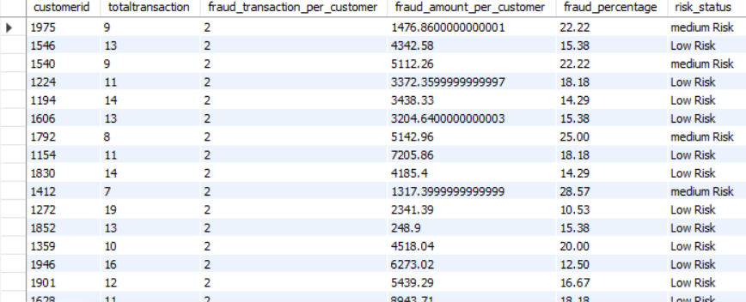

-- Calculate the moving average of Transaction Amount for each customer .
SELECT
customerid, transaction_date, amount,
avg(amount)over(partition by customerid order by transaction_date
rows between 6 preceding and current row) as moving_avg

FROM
fraud_transaction;

